OOPS Concepts in Framework

Inheritance and abstraction:

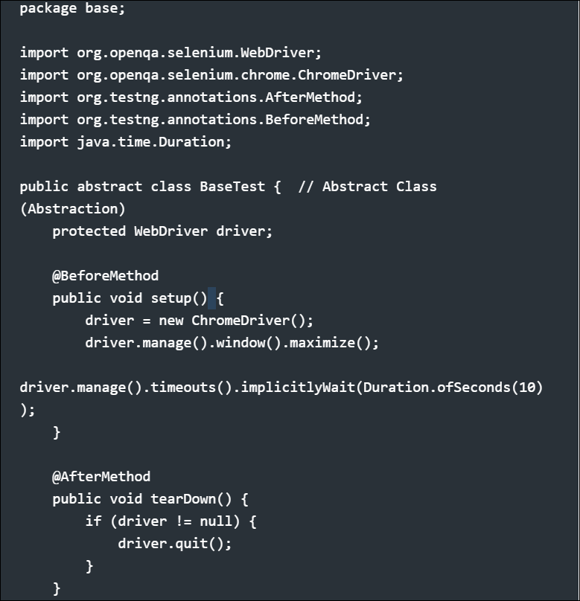

✅ Key OOP Concepts Used:
- Abstraction: The class is abstract, and test classes inherit from it.
- Inheritance: All test classes extend BaseTest to reuse setup() and tearDown().

Page Object Model (Encapsulation)
- Encapsulation is implemented by keeping web elements private and providing only necessary methods for interaction.
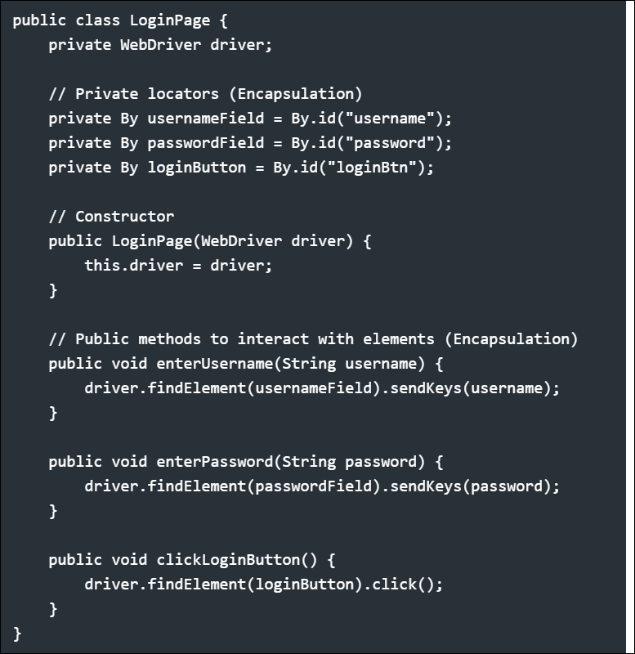

✅ Key OOP Concepts Used:
- Encapsulation: Web elements are private, and interaction happens through public methods.

Utility Class for Waits (Polymorphism - Method Overloading)
- Implements Method Overloading by defining multiple waitForElement methods with different parameters.

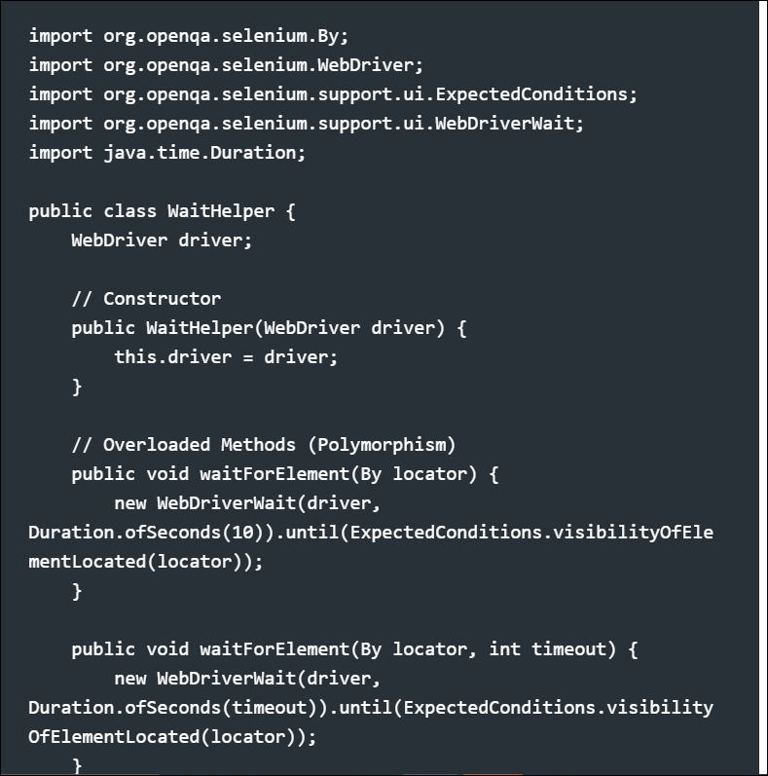
✅ Benefits:
- Flexibility to call methods with different parameter sets.
- Improves test framework efficiency and reusability.

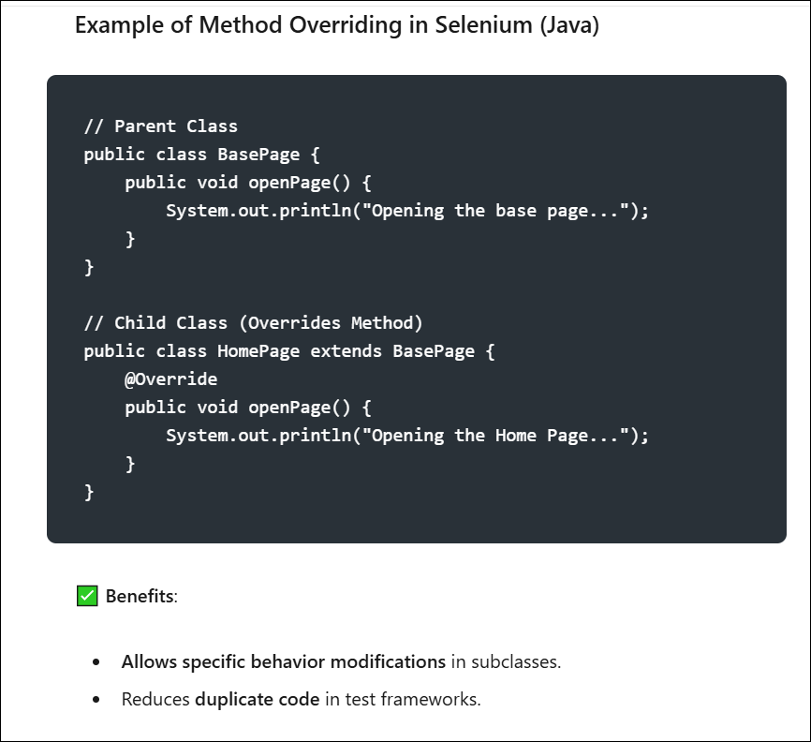

4️⃣ Test Class (Inheritance & Using Page Objects)
- Extends BaseTest, meaning it inherits setup() and tearDown().
- Uses the LoginPage (Encapsulation).
- Uses WaitHelper (Polymorphism).

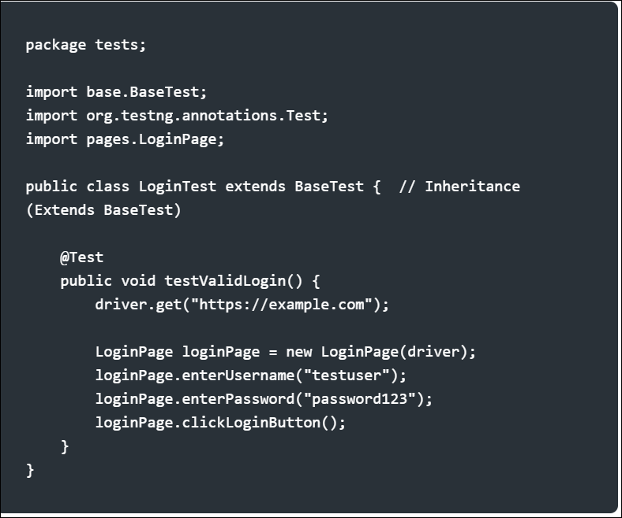

✅ Key OOP Concepts Used:
- Inheritance: LoginTest extends BaseTest and reuses setup() and tearDown().
- Encapsulation: Uses LoginPage to interact with elements.

